Solevad Consulting Website Feedback

General Formatting Feedback

* Colors teams have not been used in background which are
  + Brownish Yellow
  + Blue
  + Black
  + White and Green can be used as accent colors
* The alignment of the page does not adjust appropriately depending on the device you are using or the size of the screen. Use this website as an example

Full Screen ([Better Buildings Solution Center | Better Buildings Initiative](https://betterbuildingssolutioncenter.energy.gov/))

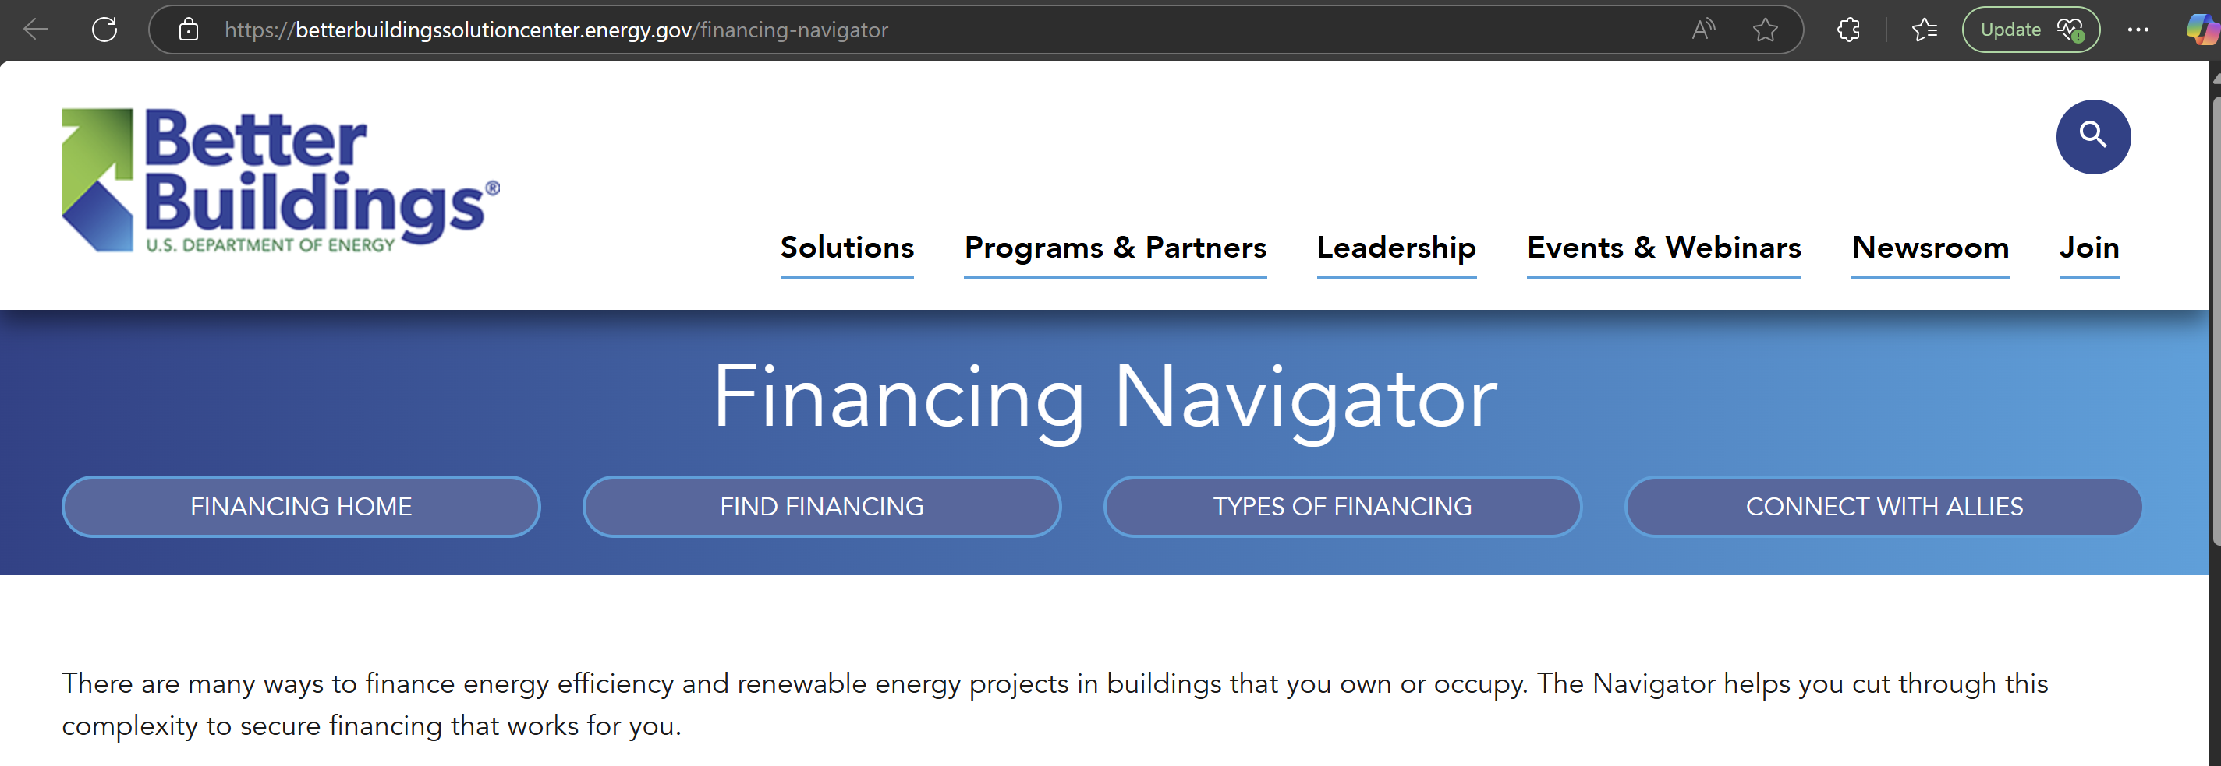

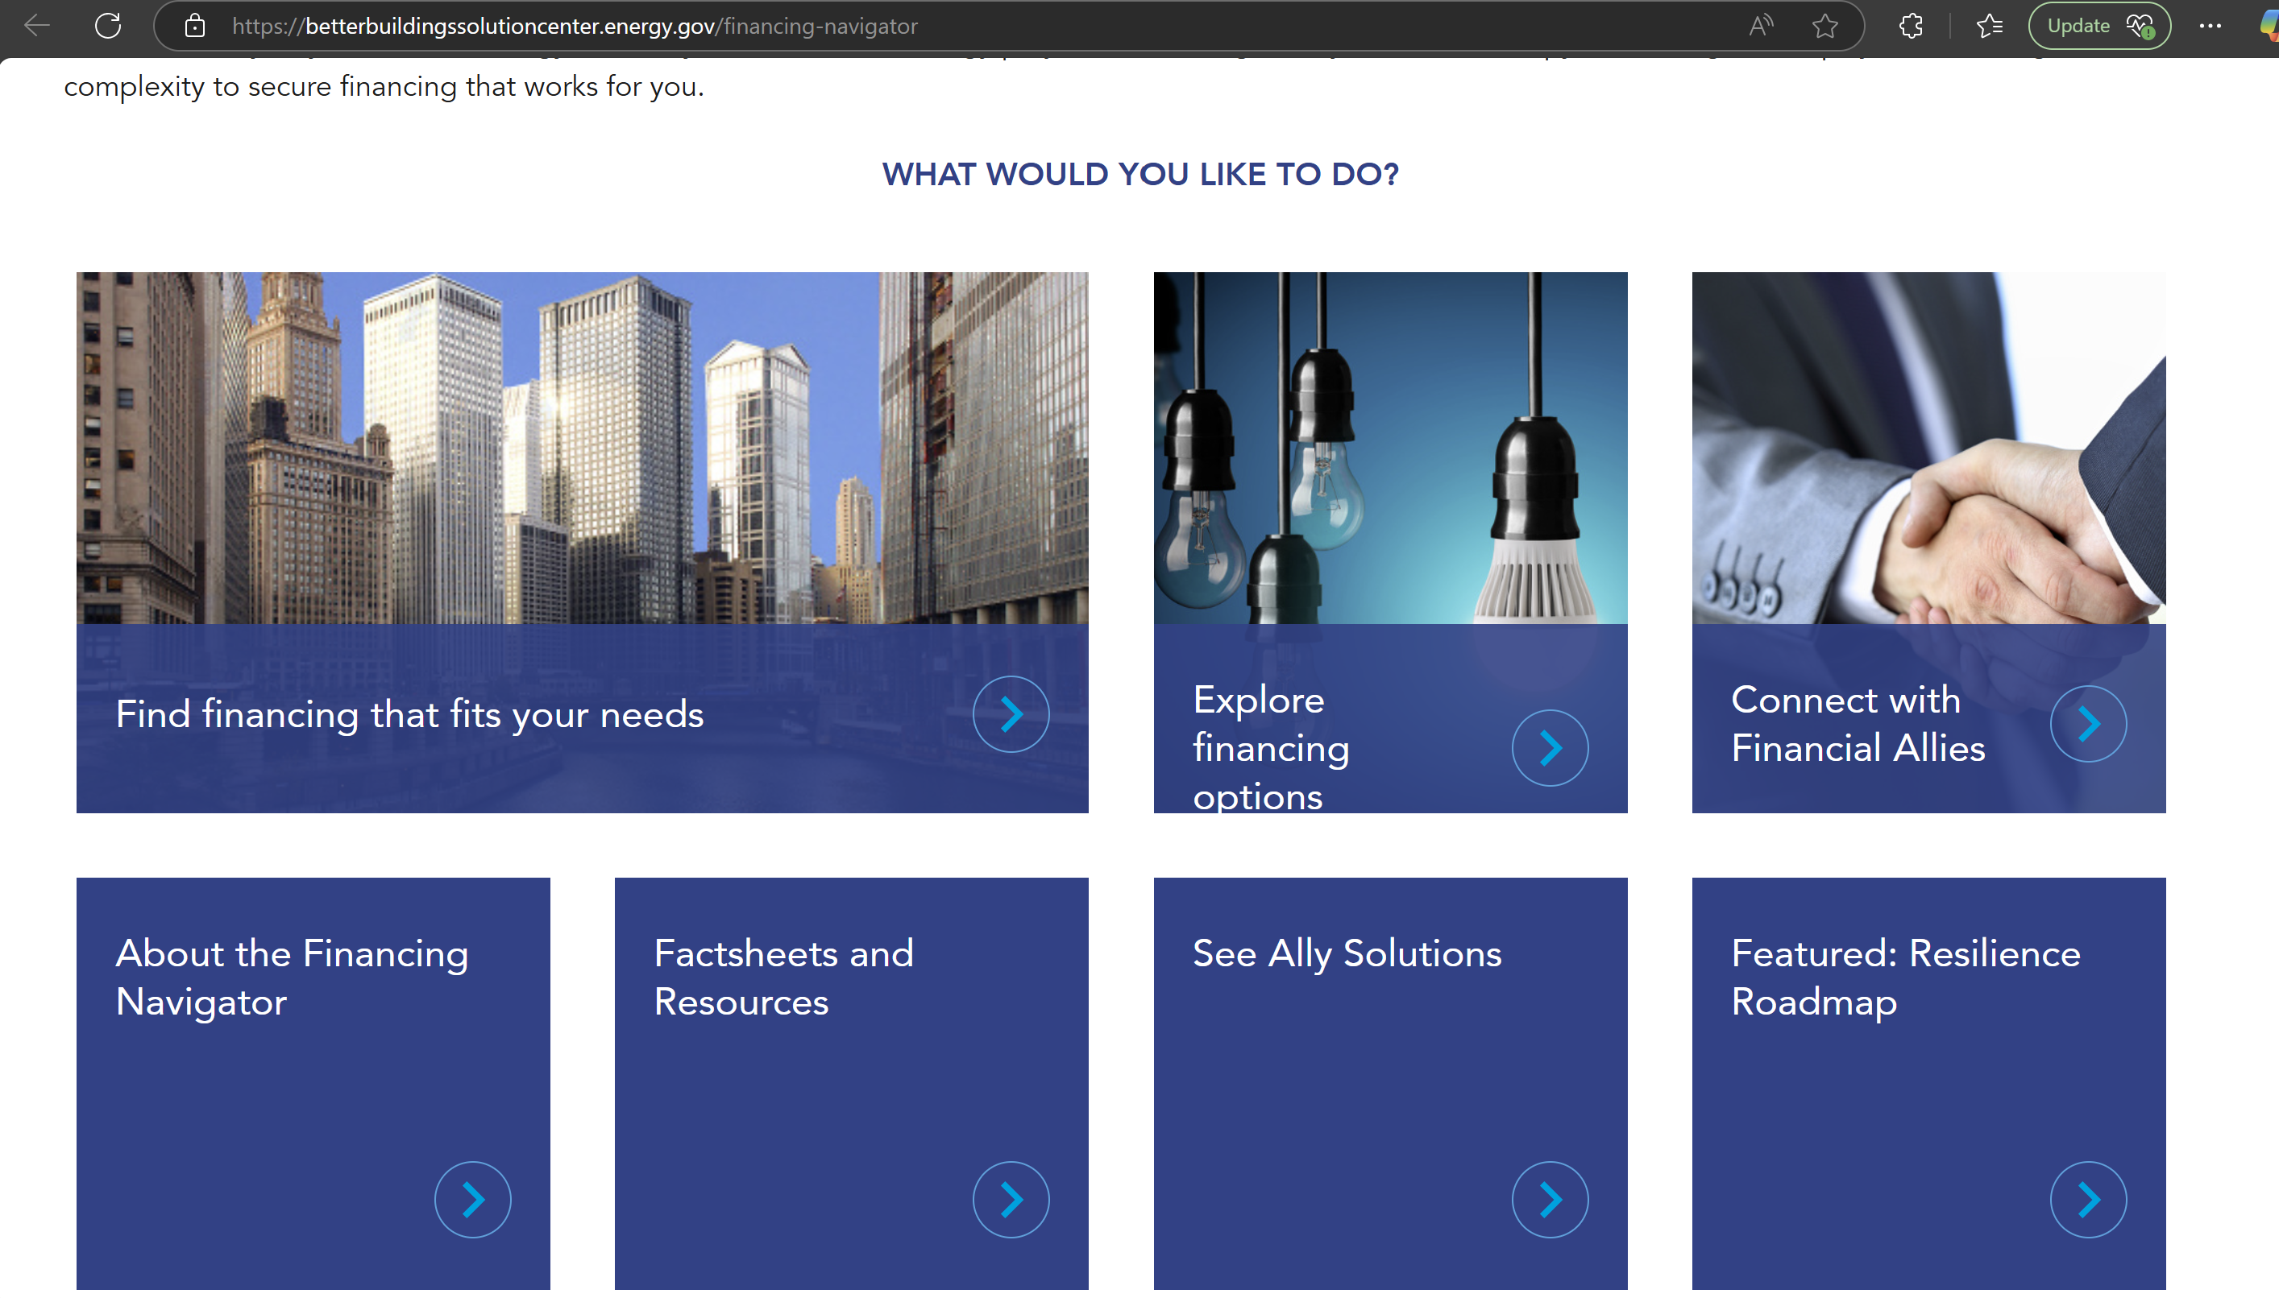

Half Screen

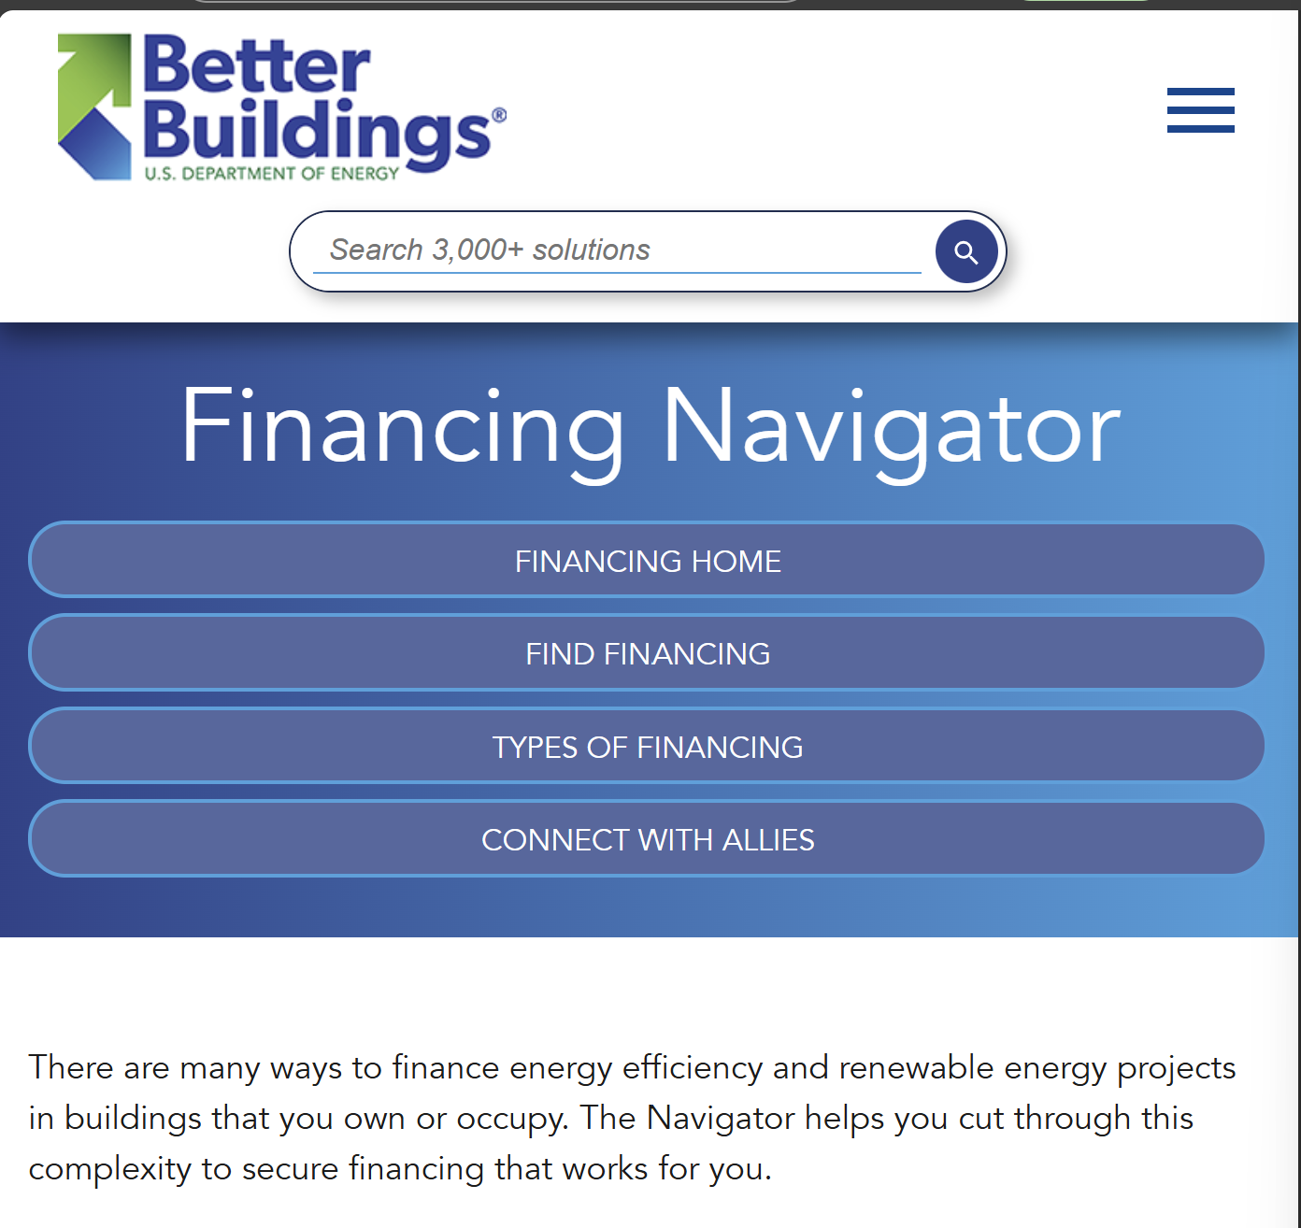

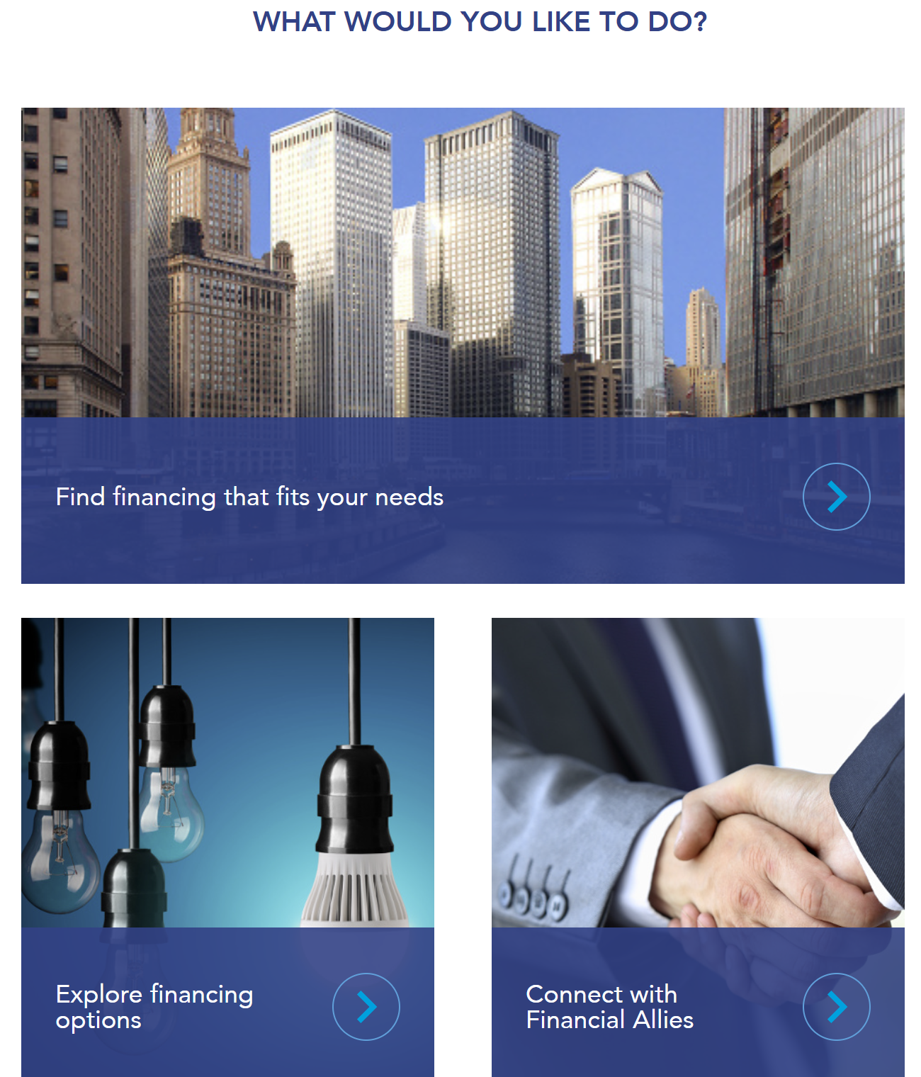

Solevad

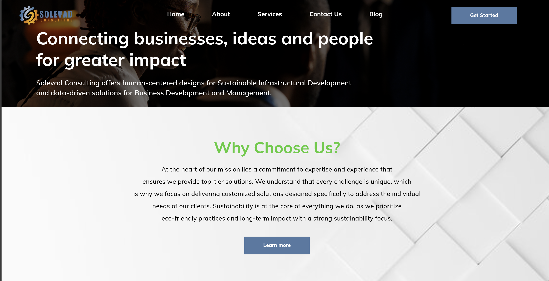

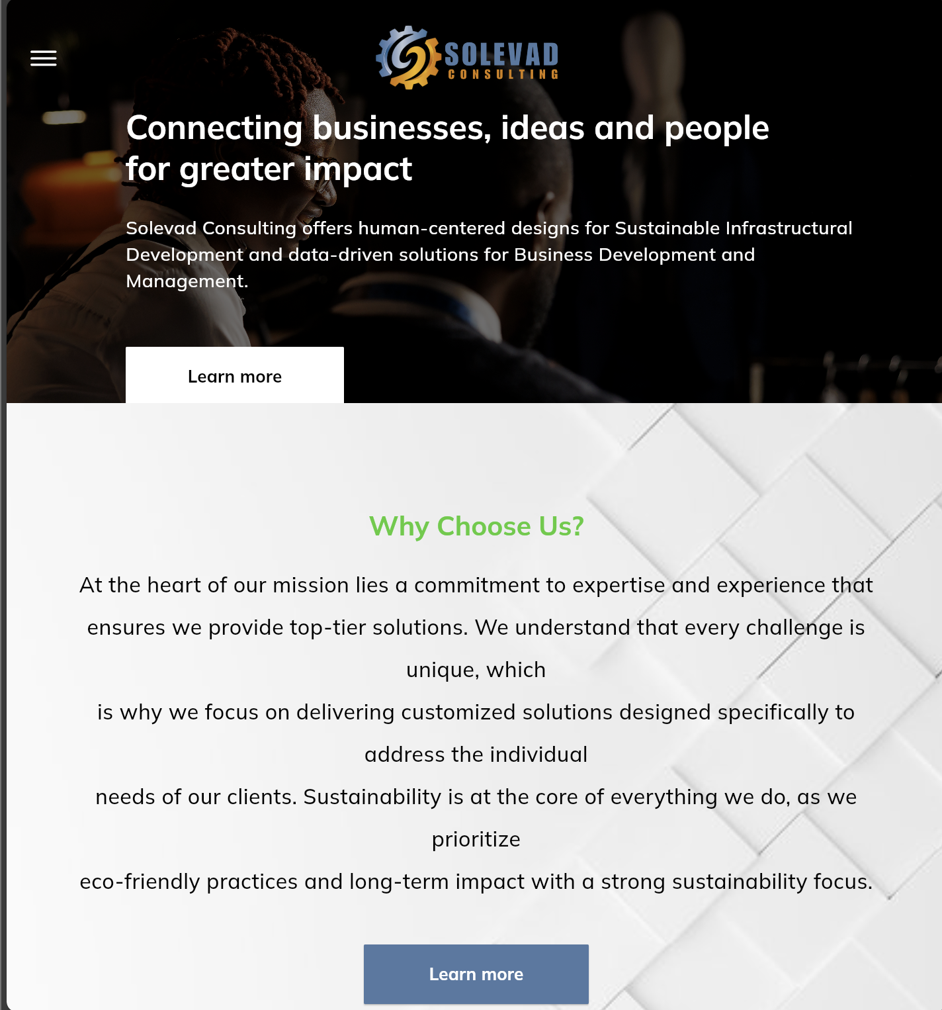

* Bullet Points: Make sure there are not more than two formats throughout the website for Bullet points . Make sure to only use arrows and circular bullet points
  + Ensure the wording is aligned when there is a bullet. Using the picture below as an example, the second line of each sentence needs to start from where the first word of the sentence started and not under the bullet point.

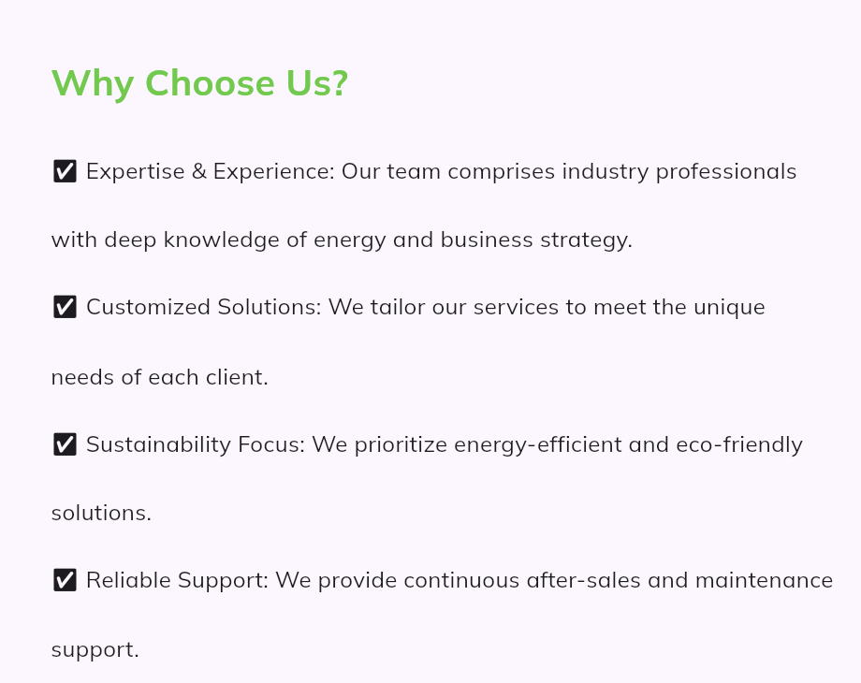

**Home Page**

* Let the first page that that shows our slogan cover the first page completely. See screenshot below as an example. ([Solveda | eCommerce Strategy and Development | AI Services](https://www.solveda.com/))

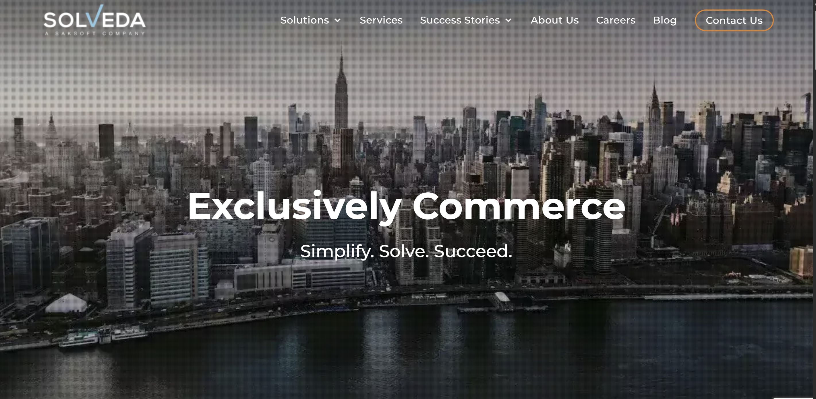

* Edit the second part of the sentence on the first page to
  + Solevad Consulting specializes in human-centered designs that drive sustainable infrastructural development and provide data driven solutions for enhancing business operations.
* There is no need for a learn more button that takes us to About us, when the second page has the same button that does the same thing
  + I recommend removing it or making the button linked to the contact us page.
* Second Page (why choose us)
  + Mostly formatting as discussed earlier.
* Third Page (Our Services) – Third and forth bullet is mostly for the services section
  + Adjust formatting as discussed earlier and previously on Solevad website.
  + Once you click on each service it does not work, it is supposed to take you to the link that breaks down the service
  + At Solevad Consulting, we are dedicated to forging meaningful connections that not only drive growth but also promote sustainability across all facets of business and community life. We understand that true impact comes from collaboration and innovation, which is why we prioritize human-centered designs in our approach. By aligning our strategies with the unique needs of our clients and the communities they serve, we empower organizations to thrive while fostering a positive social and environmental footprint. Our commitment to creating these impactful connections ensures that every project contributes to a more sustainable future, benefiting both businesses and the communities they engage with.
  + We offer a diverse range of services across three core areas:
    - **Energy Consulting**: We guide organizations in the adoption of renewable energy solutions, conduct thorough contract reviews, perform measurement and verification (M&V), and deliver comprehensive audits to optimize energy management.
      * **Renewable Energy Development:** We support organizations in adopting renewable energy solutions, from feasibility studies to project implementation. Our expertise includes solar, battery, and other renewable technologies, enabling a seamless transition to sustainable energy sources.
      * **Technical Asset Management:** We provide end-to-end technical asset management services, ensuring the optimal performance and longevity of your energy systems. Our proactive approach includes regular maintenance, performance monitoring, and troubleshooting to maximize returns on your energy investments**.**
      * **Energy Brokering:** We assist businesses in securing the most cost-effective energy rates through our energy brokering services. By leveraging our industry relationships and market insights, we negotiate contracts that align with your budget and operational needs while prioritizing sustainability.
      * **Utility Bill Monitoring:** Our utility bill monitoring services provide an in-depth analysis of your energy consumption trends. By identifying anomalies and usage patterns, we help you optimize costs and ensure billing accuracy, saving you money over time.
      * **Measurement & Verification:** We specialize in providing accurate measurement and verification (M&V) services to help clients assess the effectiveness of energy-saving measures. By tracking energy performance and validating cost savings, we ensure your investments in efficiency deliver measurable results.
      * **Compliance Reporting:** Our team ensures your organization meets all regulatory and industry compliance requirements. We prepare detailed and accurate reports that align with local, national, and international energy standards, helping you avoid penalties and maintain operational excellence.
      * **Energy Audits:** We conduct comprehensive energy audits to identify inefficiencies and uncover opportunities for energy conservation. Our detailed evaluations provide actionable recommendations to reduce operational costs while improving energy usage.
    - **Community Development**: Our focus extends to education and workforce development, where we promote community engagement and advocacy, ensuring that local voices are heard and empowered.
      * **Equitable Workforce Development**: We focus on creating inclusive opportunities that empower community members through skill-building and training programs. By prioritizing equity in workforce development, we aim to enhance economic mobility and ensure that all voices are represented in the local job market.
      * **Community Engagement & Advocacy**: Our approach emphasizes active collaboration with community stakeholders to identify and address local needs. Through advocacy efforts, we work to amplify underrepresented voices and foster a sense of ownership among community members in the development process, ensuring equitable access to resources and opportunities.
      * **Holistic Educational Initiatives**: We support educational programs that provide access to quality learning experiences for all community members. By fostering partnerships with local schools and organizations, we aim to create a more equitable educational landscape that prepares individuals for future success.
      * **Sustainable Community Projects:** We design and implement community projects that are environmentally sustainable and socially responsible. By aligning these initiatives with local needs and values, we help build resilient communities that thrive while promoting equitable development for all.
      * **Energy Policy Advocacy**: We actively engage in energy policy advocacy to promote equitable access to sustainable energy resources. By collaborating with policymakers and community leaders, we work to influence legislation that supports renewable energy initiatives and addresses energy equity, ensuring that all communities benefit from clean energy solutions.
    - **Business Consulting**: We help organizations streamline their operations through innovative technology deployment, strategic planning, and the development of effective systems that enhance overall efficiency.
      * **Strategic Planning**: We assist organizations in developing robust strategies that align with their long-term goals. Our strategic planning services focus on identifying opportunities and challenges, enabling businesses to navigate their growth paths effectively.
      * **Technology Implementation:** We guide clients through the process of selecting and implementing the right technologies to enhance operational efficiency. Our expertise ensures that technology solutions are seamlessly integrated into existing systems, maximizing their impact.
      * **Process Optimization:** Our team analyzes current operational processes to identify inefficiencies and bottlenecks. By implementing best practices and innovative solutions, we help organizations streamline operations, reduce costs, and improve overall productivity.
      * **Performance Improvement:** We work with clients to establish key performance indicators (KPIs) and facilitate continuous improvement initiatives. Our data-driven approach enables organizations to make informed decisions that enhance performance and drive sustainable growth.
* Remove
  + The industries we serve
  + Meet Our Team
  + Testimonials (This would only be temporary for now)
* Make sure to revise the frequently asked questions based on some of these website feedback.

About Us

* First page
  + Lets look for a different background picture.
  + Leave the Innovative Solutions | Expert Guidance | Sustainable Growth
  + Change the text in this section to :
    - At Solevad Consulting, we are dedicated to forging meaningful connections that not only drive growth but also promote sustainability across all facets of business and community life. We understand that true impact comes from collaboration and innovation, which is why we prioritize human-centered designs in our approach. By aligning our strategies with the unique needs of our clients and the communities they serve, we empower organizations to thrive while fostering a positive social and environmental footprint. Our commitment to creating these impactful connections ensures that every project contributes to a more sustainable future, benefiting both businesses and the communities they engage with.
* Why Choose us?
  + Industry Expertise: Experienced professionals with a profound understanding of energy consulting and business strategy, ensuring you receive top-tier insights and solutions.
  + Tailored Solutions: We recognize that every client is unique. Our services are meticulously customized to align with your specific challenges and goals, delivering impactful results.
  + Commitment to Sustainability: We actively promote eco-friendly practices by prioritizing energy-efficient solutions that not only enhance your operations but also contribute to a healthier planet.
  + Comprehensive Support: We foster enduring partnerships with our clients by providing reliable ongoing support, ensuring you have the resources and assistance needed for sustained success.
* Third & Forth Page
  + Mission
    - At Solevad Consulting, our mission is to deliver human-centered, innovative solutions that empower businesses, communities, and individuals to achieve sustainable growth and transformative impact. Through our expertise in energy consulting, community development, and business optimization, we aim to connect businesses, ideas, and people to create meaningful, data-driven strategies that promote operational efficiency, environmental stewardship, and social progress.
  + Vision
    - Our vision is to be a global leader in sustainable consulting, recognized for creating lasting connections between businesses and communities that drive economic, social, and environmental transformation. We strive to build a future where organizations thrive by embracing renewable energy, innovative technologies, and community-focused solutions, contributing to a world that values collaboration, equity, and sustainability as the cornerstones of progress.

Contact Us

* Address : 4245 N Central Expy, #490. Dallas TX 75205
* Email : [Operations@solevadaa.com](mailto:Operations@solevadaa.com)
* Phone : 469-544-6914